

**Job role:**

**Data Engineer**

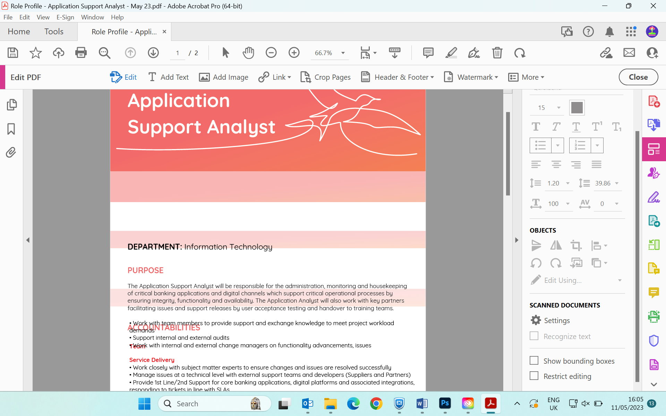

**Band**: Technical/Professional

**Responsible to**: Head of IT

**Department:** Information Technology

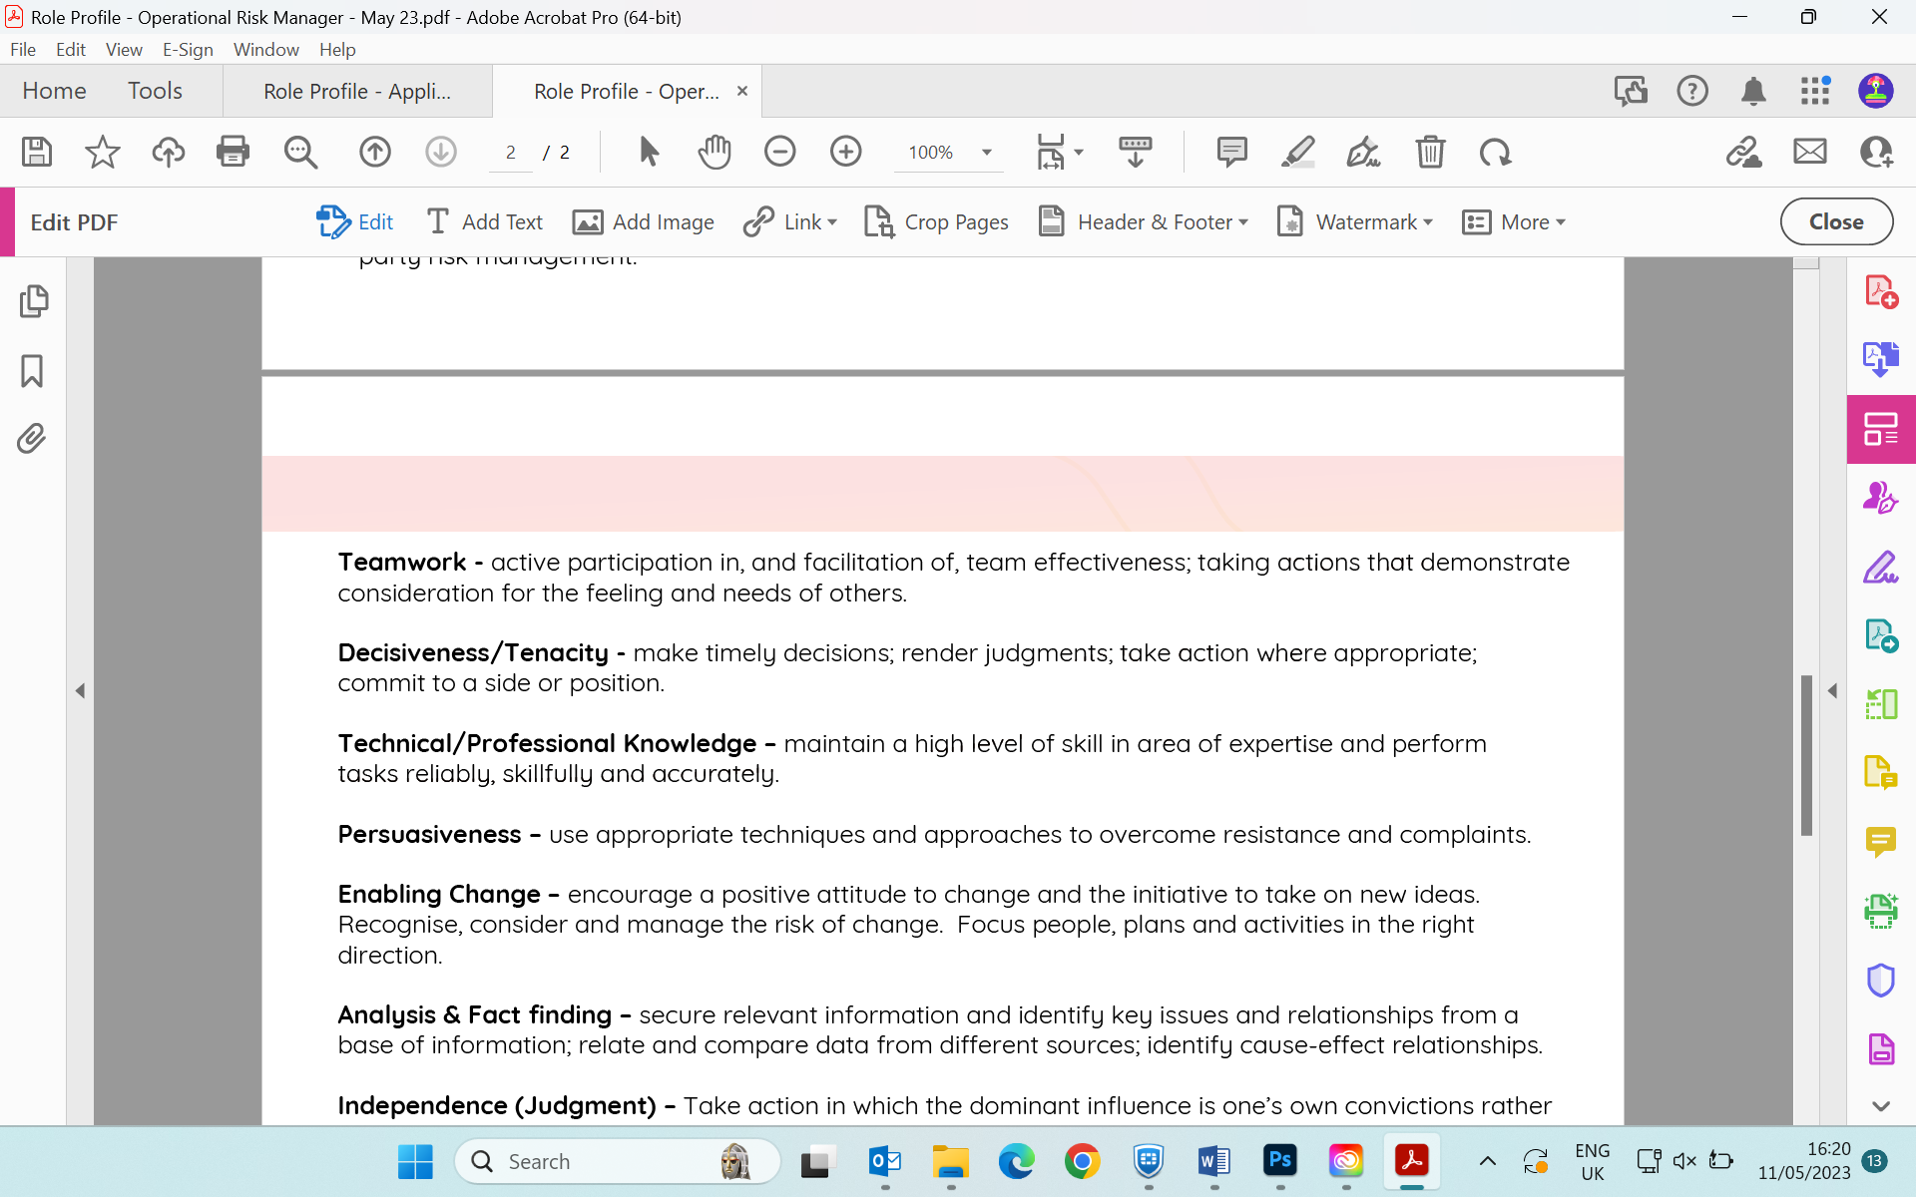

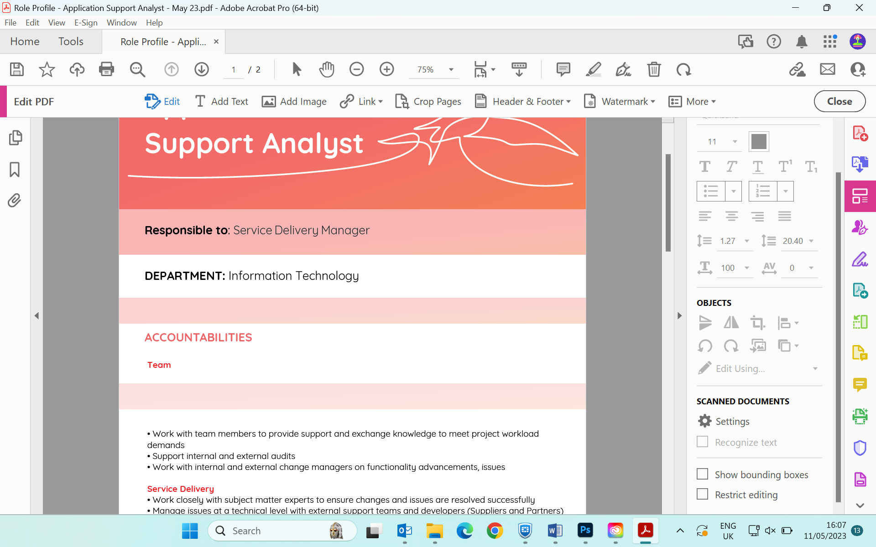

**PURPOSE**

The Data Engineer will work closely with IT, Finance and Operations to deliver the business reporting requirements within a timely and consistent manner. They are required to develop and provide trusted data on performance, financial positions to aid decision making across the business. They also to provide tactical information to end users to support process.

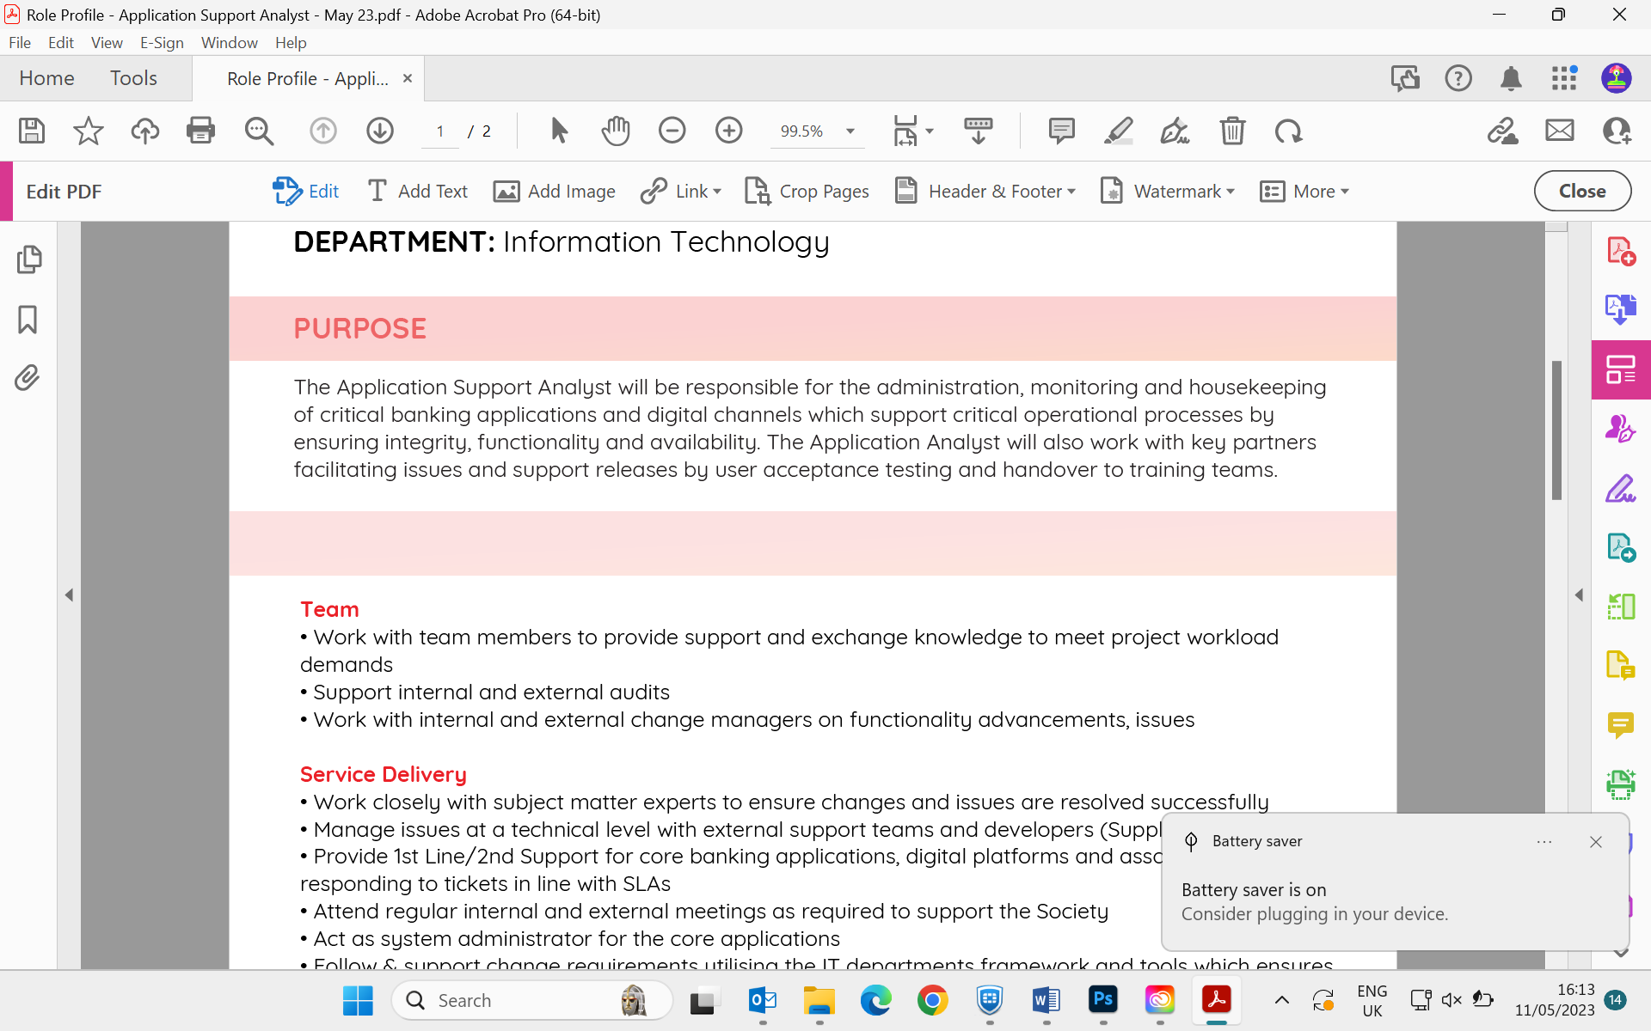

**ACCOUNTABILITIES**



* Demonstrates an aptitude to compile data into comprehensive reports, analyse trends, and make recommendations based off findings
* Excellent communication skills - written and verbal, with an ability to convey complex information to a broad audience
* Comfortable and flexible working in a fast paced environment
* Self-motivated with the ability to prioritise effectively to meet deadlines
* An ability to build strong relationships with internal and external stakeholders
* Positive "can do" attitude and highly analytical; enjoys challenges
* Strong interpersonal skills with ability to work independently and within a team
* Detail oriented and comfortable working with large data sets

**CORE COMPETENCIES**

* Manage presentational reporting to support decision making by Management, Committees and Board
* Work with management to aid the society’s ongoing Data Strategy
* Automate the collection of disparate data sources to Data Lakes and Data Warehouses
* Production of underlying SQL (tables, views, stored procedures, SSIS packages etc.) to enable production of critical datasets.
* Work closely with the subject matter experts to ensure data accurately reflects the business requirements
* Work across all functions to test and produce reporting solutions
* Publish team specific interactive dashboards with conclusions
* Demonstrate a thorough understanding of the data within our core systems
* Develop timely, efficient and reliable reporting solutions
* Integrate reporting solutions into the wider business applications
* Manage Tableau, ADF and SQL Server reporting deployments
* Create, maintain and produce ad-hoc reports; support specific data investigations
* Enable self-service business intelligence that give business end-users access to information without direct IT involvement
* Analyse data to create and support business cases and effect change within the business
* Conduct any administration duties required across reporting ecosystem
* Work closely with IT team to exploit Infrastructure technology to optimise production

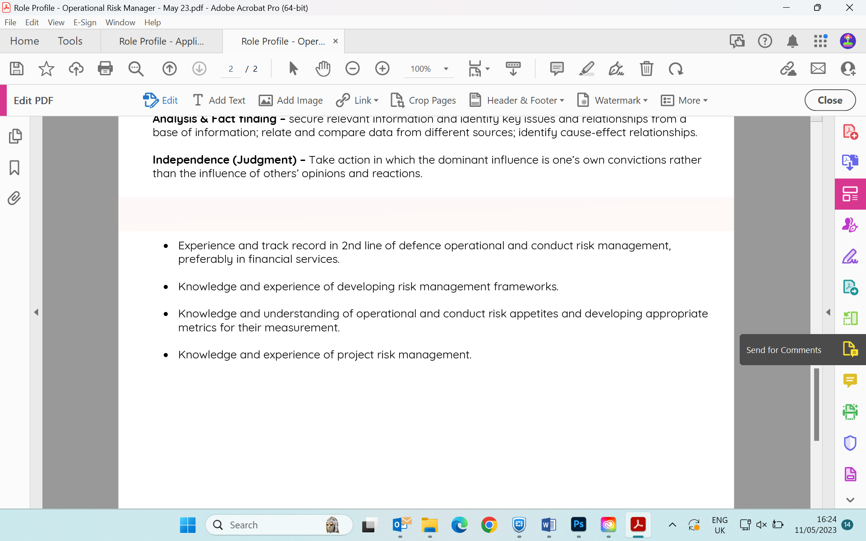

**KNOWLEDGE/SKILL/EXPERIENCE**



* Hold qualifications in related disciplines such as Statistics, Mathematics and Data Sciences
* Experienced in working Microsoft Cloud Data and Automation technologies
* Experienced working with Tableau and or Power BI
* Experienced in data warehousing for SQL Server and or ADF
* Experienced working with Windows SQL Servers
* Experienced in SSIS XML and other forms of data transformations
* Experienced in writing SQL scripts including procedures in Oracle and T-SQL
* Proficient in Excel
* Experienced in creating presentation layers and business intelligence pyramids